AN EFFICIENT NOVEL APPROACH FOR PREDICTING STARTUP COMPANY SUCCESS RATES USING ADVANCED MACHINE LEARNING PARADIGMS
Block Diagrams (all)
Department of Computer Science and Engineering, [COLLEGE NAME]
Batch C10 (CSE-C) · Academic year [ACADEMIC YEAR]
Table 1: Project team
S.No. | Student name | Roll number
1 | Orchu Shirisha | 23K91A05H6
2 | Mudavath Raghavendar | 23K91A05G1
3 | Majgi Vaishnavi | 23K91A05E0
4 | Polishetty Poojitha | 23K91A05J4

Project guide: P Prasanna
Chapter and section numbers quoted in the text (for example Chapter 8 or Section 6.2) refer to the full project report, 17.Final Document. Figures and tables in this document are numbered from 1.

1. INDEX OF DIAGRAMS
Every diagram was generated from the real design by scripts/docs_build/make_diagrams.py (matplotlib, 150 dpi) and mirrors the code in app/main.py, app/services/ and app/ml/. The application has no SQL database, so the entity-relationship diagram shows its file-based data model.
Table 2: Diagrams in this document
No. | Diagram | Image file
1 | System architecture | docs/diagrams/01_system_architecture.png
2 | High-level workflow | docs/diagrams/02_high_level_workflow.png
3 | Data flow diagram, level 0 (context) | docs/diagrams/03_dfd_level0.png
4 | Data flow diagram, level 1 | docs/diagrams/04_dfd_level1.png
5 | Data flow diagram, level 2 (processes 2.0 and 3.0) | docs/diagrams/05_dfd_level2.png
6 | UML class diagram | docs/diagrams/06_uml_class_diagram.png
7 | Sequence diagram: predicting one startup | docs/diagrams/07_sequence_diagram.png
8 | Use case diagram | docs/diagrams/08_use_case_diagram.png
9 | Entity-relationship diagram (file-based data model) | docs/diagrams/09_er_diagram.png
10 | Flowchart of the core algorithm | docs/diagrams/10_core_algorithm_flowchart.png
11 | Evaluation protocol | docs/diagrams/11_evaluation_protocol.png

2. DIAGRAMS

System architecture
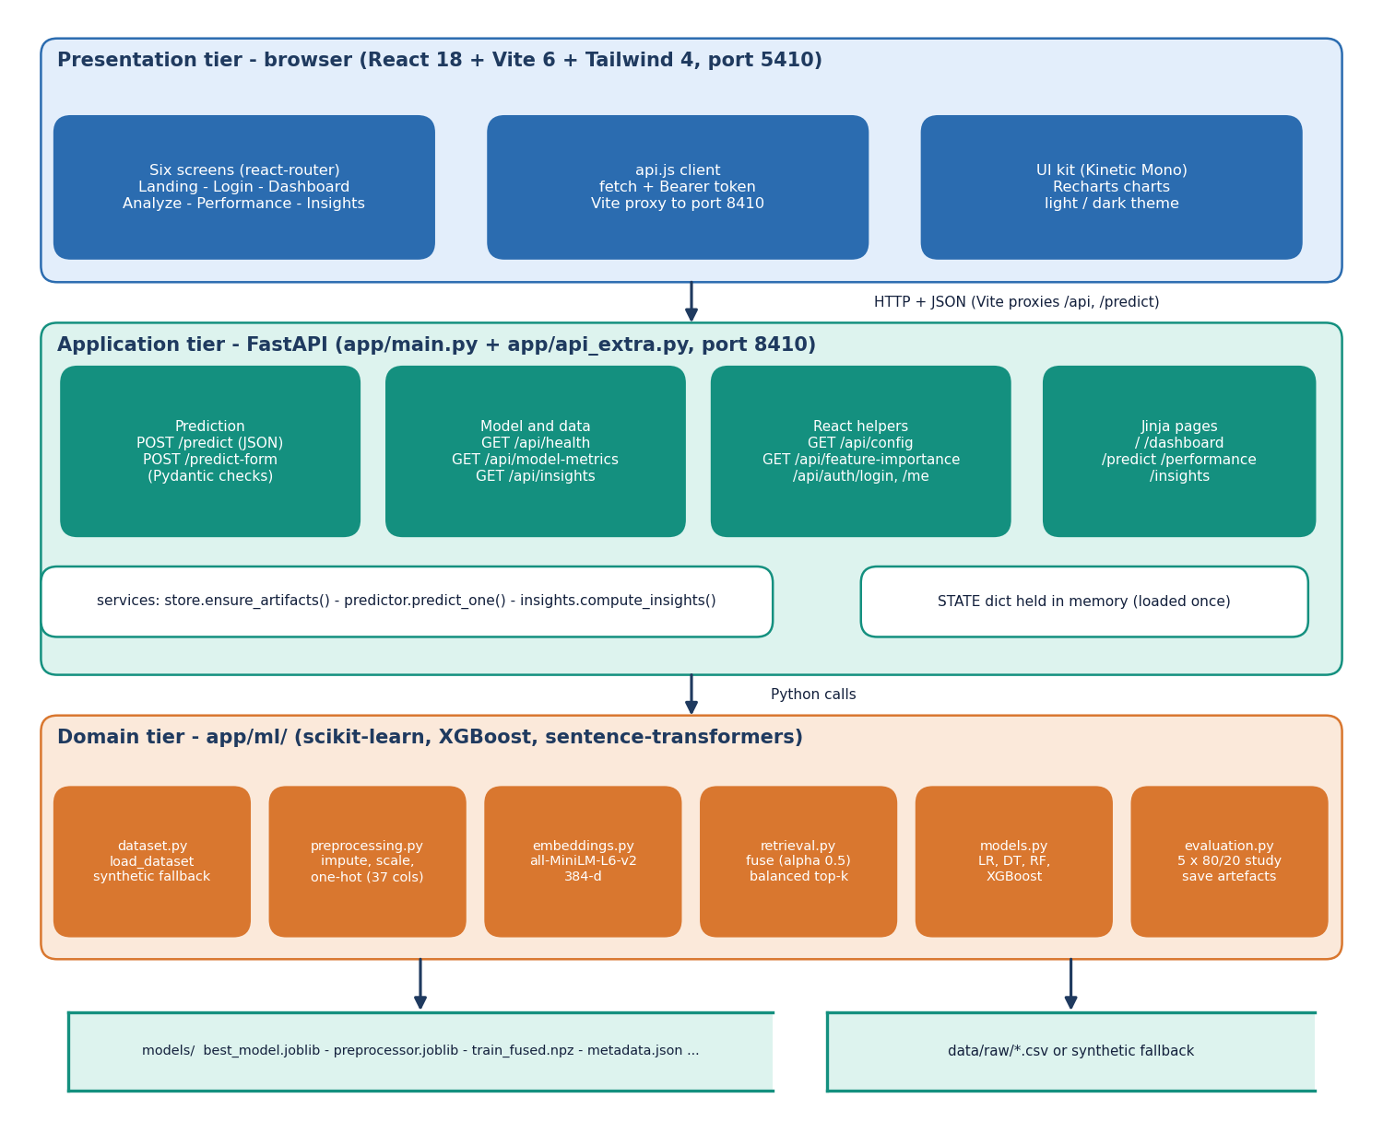
Figure 1: System architecture of VenturePulse: presentation, application and domain tiers over two stores.
The system has three tiers over two stores. The presentation tier is a React 18 single-page application built with Vite 6 and Tailwind CSS 4 and served on port 5410; it has six screens (the landing page, the sign-in and the Dashboard, Analyze, Performance and Insights screens), an API client that adds the bearer token and sends every call through the Vite proxy to port 8410, and a UI kit with Recharts charts and a light and dark theme. The application tier is the FastAPI service (app/main.py and app/api_extra.py, port 8410) with four groups of routes: prediction (POST /predict, POST /predict-form), model and data (/api/health, /api/model-metrics, /api/insights), React helpers (/api/config, /api/feature-importance, /api/auth/login and /api/auth/me) and the original Jinja pages. Three services (store.ensure_artifacts, predictor.predict_one and insights.compute_insights) and one STATE dictionary, loaded once, keep the routes thin. The domain tier is app/ml/ with six modules (dataset, preprocessing, embeddings, retrieval, models and evaluation) built on scikit-learn, XGBoost and sentence-transformers. The two stores are the models/ folder (best model, preprocessor, fused training vectors, metadata) and the CSV in data/raw/ or, if there is none, the synthetic fallback. There is no SQL database.

High-level workflow
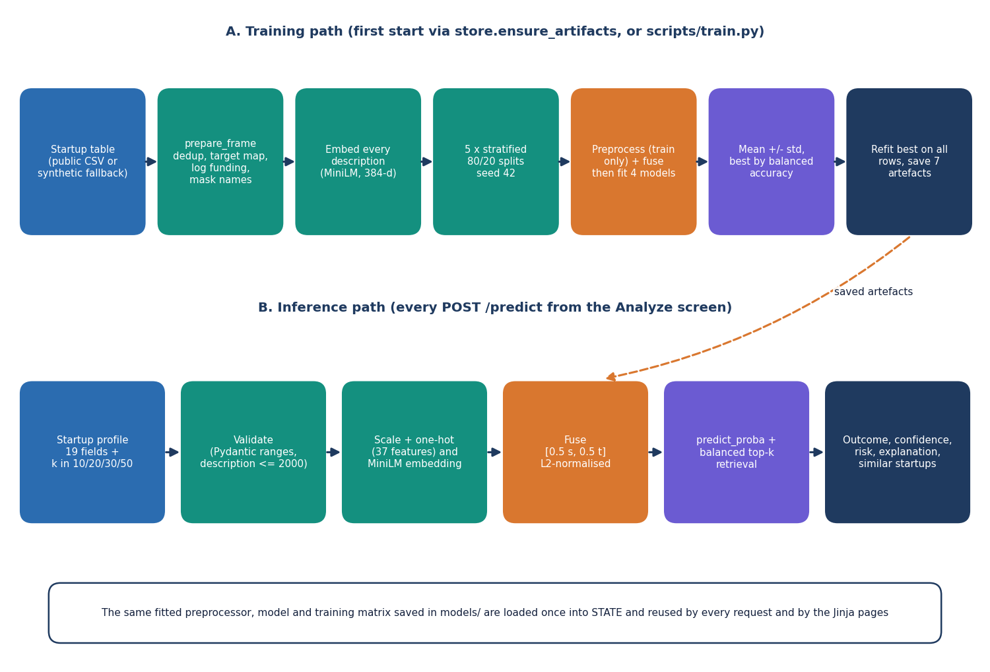
Figure 2: High-level workflow: the training path (first start or scripts/train.py) and the inference path (every POST /predict).
The workflow has two paths that share the saved artefacts. Path A starts from the startup table (the public CSV or the synthetic fallback), removes duplicates, maps the target (acquired or IPO to 1, closed to 0), adds the log of the funding and masks company names, embeds every description once with MiniLM, and runs five stratified 80/20 splits with seed 42. In each split the preprocessor is fitted on the training part only, the blocks are fused and four models are fitted; the mean and standard deviation are taken, the best model by balanced accuracy is refitted on all rows and seven artefacts are saved. Path B takes a startup profile (19 fields) and k, validates it against the Pydantic ranges and the 2,000-character limit, scales and one-hot encodes the structured fields and embeds the description, fuses the two, and obtains the probabilities and the balanced top-k retrieval; the result is the outcome, confidence, risk label, explanation and the similar startups. The same fitted preprocessor, model and training matrix are loaded once into STATE and used by every request and by the Jinja pages.

Data flow diagram, level 0 (context)
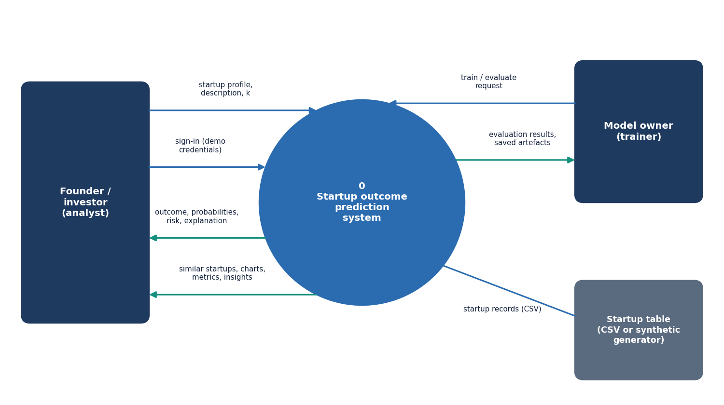
Figure 3: Level 0 data flow diagram: the system as one process with three external entities.
At the context level VenturePulse is one process. The founder or investor (the analyst) sends the demo credentials and a startup profile with a description and k, and receives the outcome, probabilities, confidence, risk and explanation, and also the similar startups, charts, model metrics and insights. The model owner (the trainer) sends a train and evaluate request and receives the evaluation results and the saved artefacts. The startup table, a CSV or the synthetic generator, supplies the startup records.

Data flow diagram, level 1
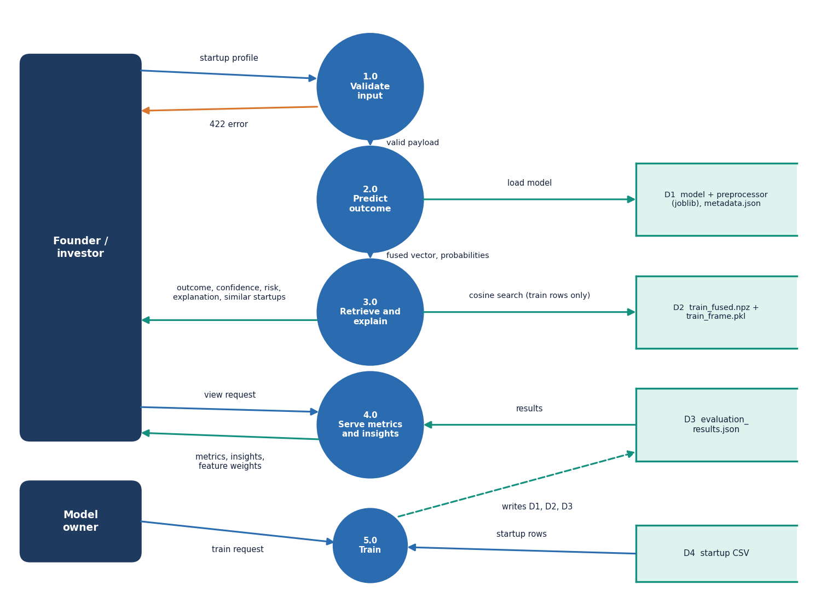
Figure 4: Level 1 data flow diagram: five processes and four data stores.
Level 1 has five processes. 1.0 Validate input receives the startup profile from the founder or investor, answers with a 422 error if a value is outside its range, and otherwise passes a valid payload on. 2.0 Predict outcome loads the model and the preprocessor from D1 (joblib files and metadata.json) and produces the fused vector and the probabilities. 3.0 Retrieve and explain runs the cosine search over D2 (train_fused.npz and train_frame.pkl, training rows only) and returns the outcome, confidence, risk, explanation and the similar startups to the user. 4.0 Serve metrics and insights reads the results from D3 (evaluation_results.json) and returns metrics, insights and feature weights on request. 5.0 Train takes the train request of the model owner and the startup rows from D4 (the startup CSV) and writes the artefacts and results. The demo sign-in (/api/auth/login) is not drawn as a process because it handles no startup data. Processes 2.0 and 3.0 are expanded in the level 2 diagram.

Data flow diagram, level 2 (processes 2.0 and 3.0)
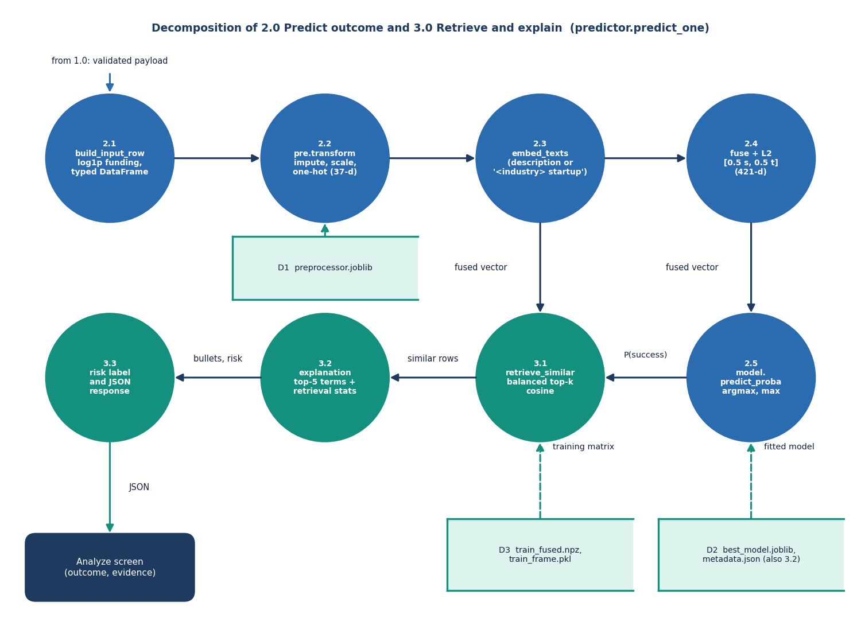
Figure 5: Level 2 data flow diagram: the steps inside 2.0 Predict outcome and 3.0 Retrieve and explain (predict_one).
Process 2.0 has five steps. 2.1 build_input_row turns the validated payload into a typed one-row table and adds the log of the funding. 2.2 pre.transform imputes, scales and one-hot encodes it into 37 structured values using the fitted preprocessor from D1. 2.3 embed_texts embeds the description into 384 values, or the text "<industry> startup" when the description is empty. 2.4 fuses the two blocks with weight 0.5 each and scales to unit length, giving a 421-value vector. 2.5 predict_proba gives the probabilities and the outcome is the larger one. Process 3.0 has three steps. 3.1 retrieve_similar ranks the training matrix D2 by cosine similarity and keeps a balanced top-k. 3.2 builds the explanation from the top five model weights and the retrieval statistics. 3.3 adds the risk label and returns the JSON response to the Analyze screen.

UML class diagram
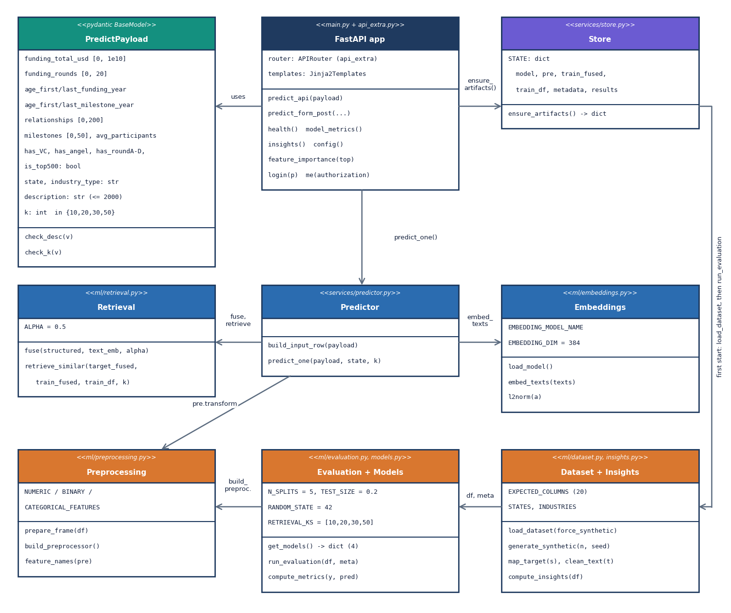
Figure 6: UML class diagram of the main classes and modules.
The code is organised as small modules with one validation class, and the diagram shows both. PredictPayload is the Pydantic model with the field ranges and the validators check_desc and check_k. The FastAPI app (app/main.py plus app/api_extra.py) holds the route functions (predict_api, predict_form_post, health, model_metrics, insights, config, feature_importance, login, me). The Store module owns the STATE dictionary and ensure_artifacts. The Predictor module has build_input_row and predict_one, which uses Retrieval (fuse, retrieve_similar, with the constant ALPHA = 0.5), Embeddings (load_model, embed_texts, l2norm) and Preprocessing (prepare_frame, build_preprocessor, feature_names). Evaluation + Models holds get_models, run_evaluation and compute_metrics with N_SPLITS = 5, TEST_SIZE = 0.2 and RANDOM_STATE = 42, and Dataset + Insights holds load_dataset, generate_synthetic, map_target, clean_text and compute_insights. Arrows show which module calls which: the app validates and calls the store and the predictor; the store reads the artefacts and, on a first run, loads the dataset and runs the evaluation.

Sequence diagram: predicting one startup
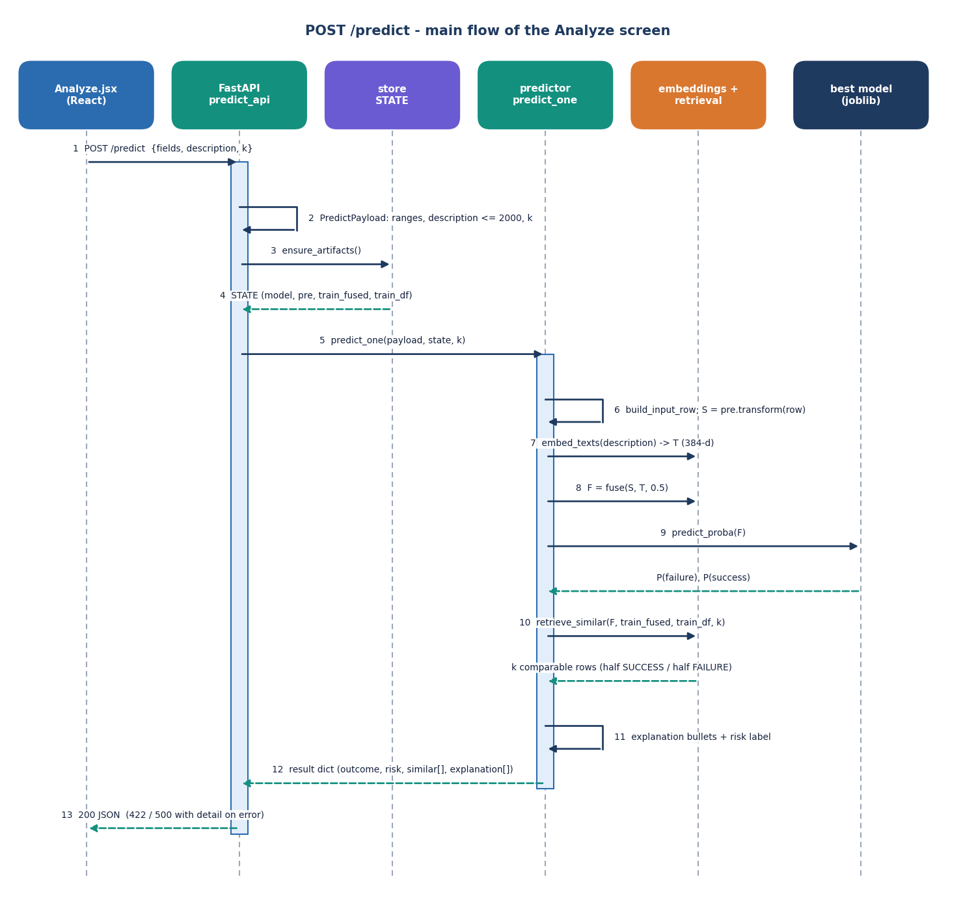
Figure 7: Sequence diagram of one POST /predict request, from the Analyze screen to the model and back.
The Analyze page posts the fields, the description and k (step 1). FastAPI validates them with the Pydantic model (2) and returns 422 if they are invalid. The route calls ensure_artifacts (3) and gets the loaded STATE (4), then calls predict_one (5). The predictor builds the typed row with the log of the funding (6) and transforms it with the preprocessor into 37 values (7), asks the embedding module for the 384-value description vector (8), fuses the two (9) and calls predict_proba on the best model (10), which returns P(failure) and P(success); the outcome is the arg-max and the confidence the maximum. It then retrieves the k comparable rows, half SUCCESS and half FAILURE (11), builds the explanation bullets and the risk label (12) and returns the result (13). The route answers with 200 and the JSON, or 422 or 500 with a detail message (14).

Use case diagram
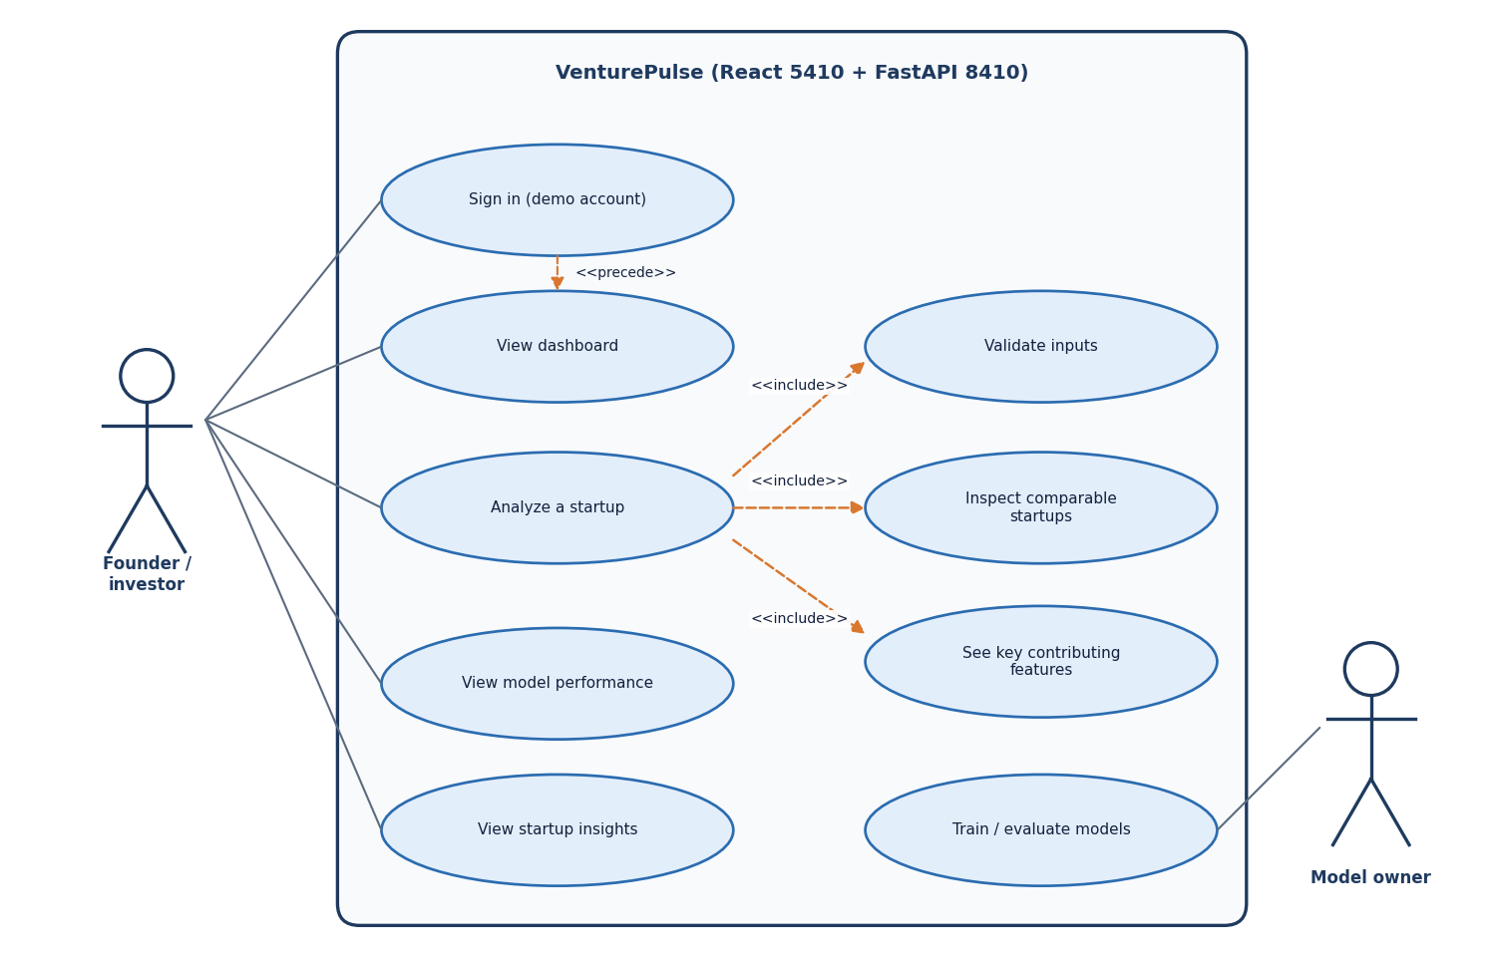
Figure 8: Use case diagram: two actors and eight use cases of VenturePulse.
The founder or investor signs in with the demo account, which precedes the other use cases, and can view the dashboard, analyse a startup, view the model performance and view the startup insights. Analysing a startup includes validating the inputs, inspecting the comparable startups and seeing the key contributing features. The model owner can train and evaluate the models (the scripts and the first-start training) and view the startup insights. The product has one demo account; the two actors only show who typically starts which use case.

Entity-relationship diagram (file-based data model)
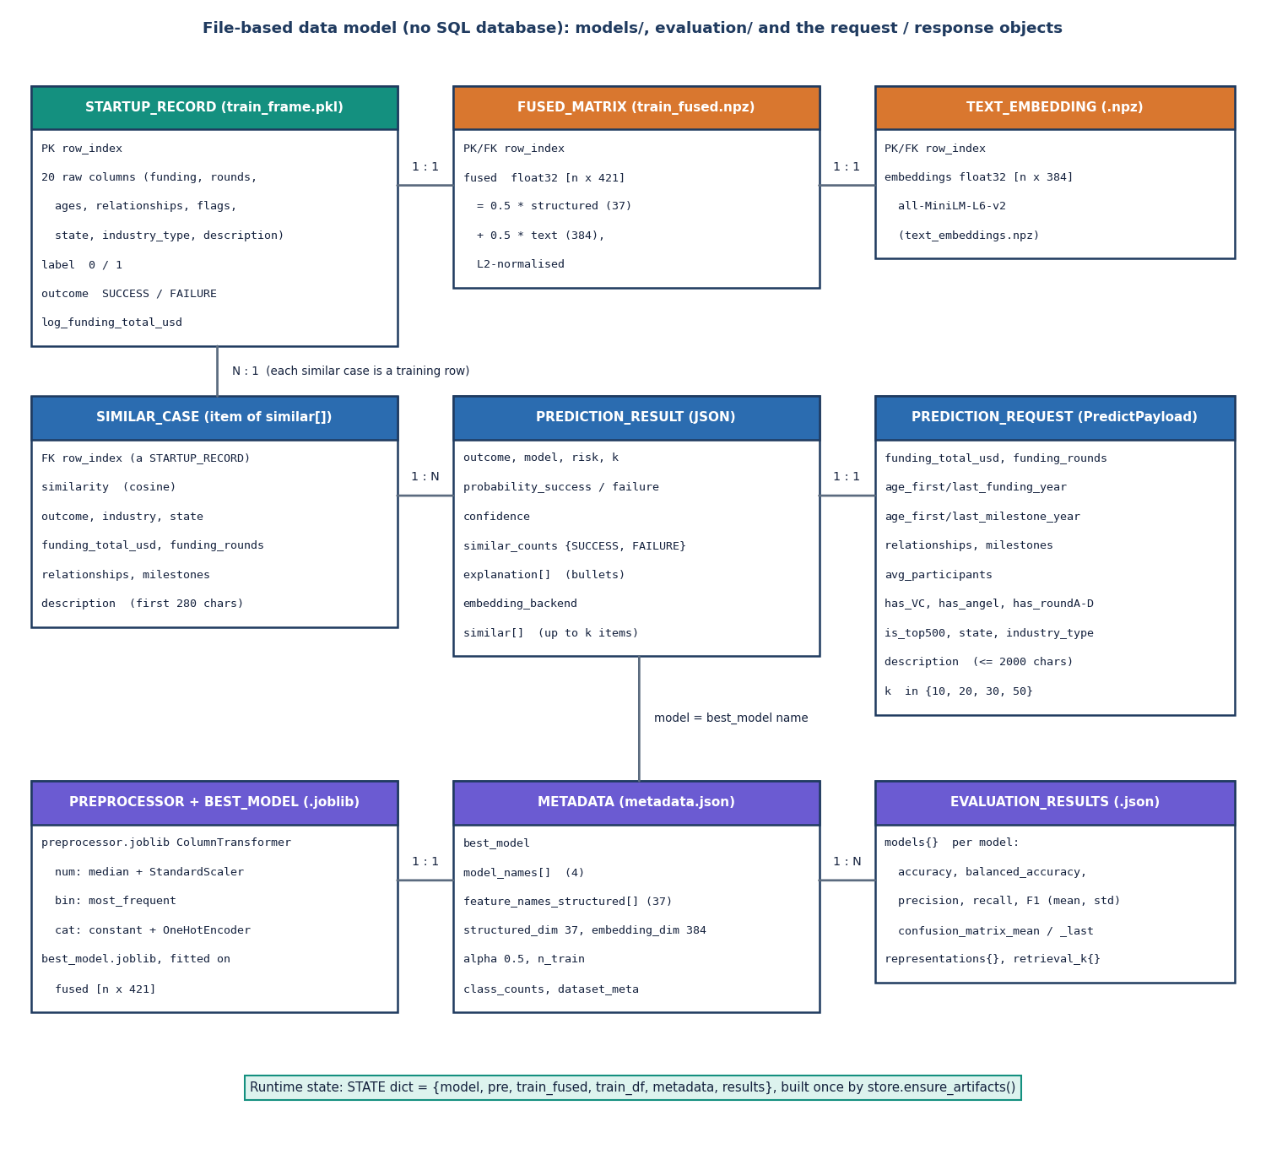
Figure 9: Entity-relationship diagram of the data model; the product has no SQL database.
VenturePulse stores its data in files. The STARTUP_RECORD table (train_frame.pkl) holds the 20 raw columns of a startup, the label, the outcome and the log of the funding; it is aligned one to one with the FUSED_MATRIX (train_fused.npz, 421 values per row) and the TEXT_EMBEDDING (text_embeddings.npz, 384 values per row). A PREDICTION_REQUEST (the PredictPayload) produces one PREDICTION_RESULT, which contains up to k SIMILAR_CASE items taken from STARTUP_RECORD at request time, and names the best model. The fitted PREPROCESSOR and BEST_MODEL (.joblib) are described by the METADATA file (best model, model names, 37 feature names, alpha, class counts, dataset source), and the EVALUATION_RESULTS file holds the mean and standard deviation of every metric for each model. Requests and results are transient; the STATE dictionary holds the loaded files while the server runs.

Flowchart of the core algorithm
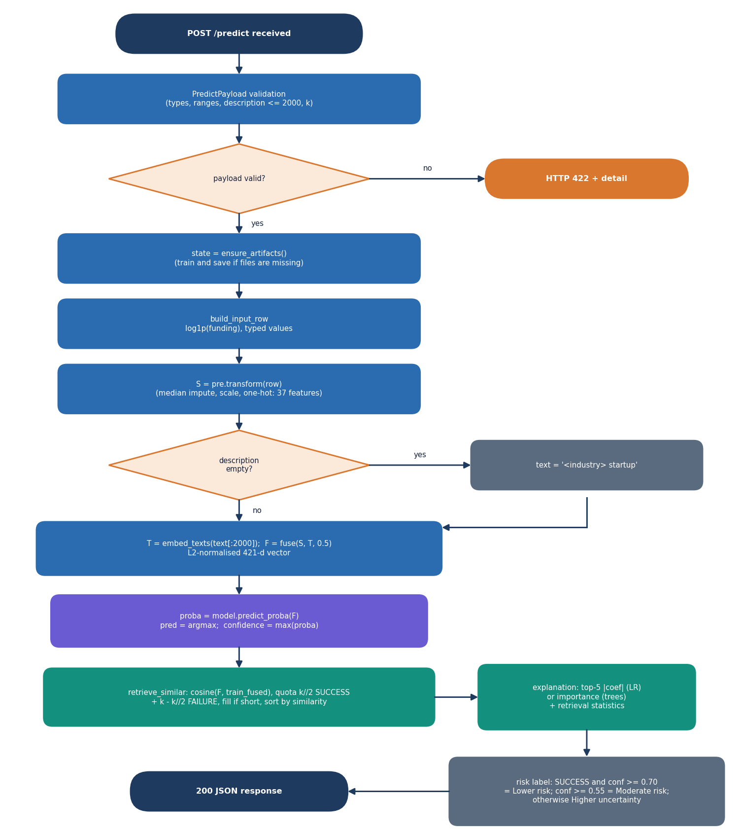
Figure 10: Flowchart of the core algorithm: validation, fusion, classification, balanced retrieval and the risk label.
The flowchart follows POST /predict. The payload is validated (types, ranges, description at most 2,000 characters, k in the whitelist) and an invalid payload ends in HTTP 422. ensure_artifacts loads or, if files are missing, builds the artefacts. The typed row with the log of the funding is transformed into the structured vector; an empty description is replaced by "<industry> startup"; the text is embedded and fused with alpha = 0.5 into a unit-length 421-value vector. The model gives the probabilities; the outcome is the arg-max and the confidence the maximum. retrieve_similar picks k//2 SUCCESS and k - k//2 FAILURE rows by cosine similarity (a shortfall is filled from the nearest remaining rows) and the explanation is built from the top five model weights and the retrieval statistics. Finally the risk label is "Lower risk" if the outcome is SUCCESS with confidence at least 0.70, "Moderate risk" if the confidence is at least 0.55, and "Higher uncertainty" otherwise, and the JSON response is returned.

Evaluation protocol
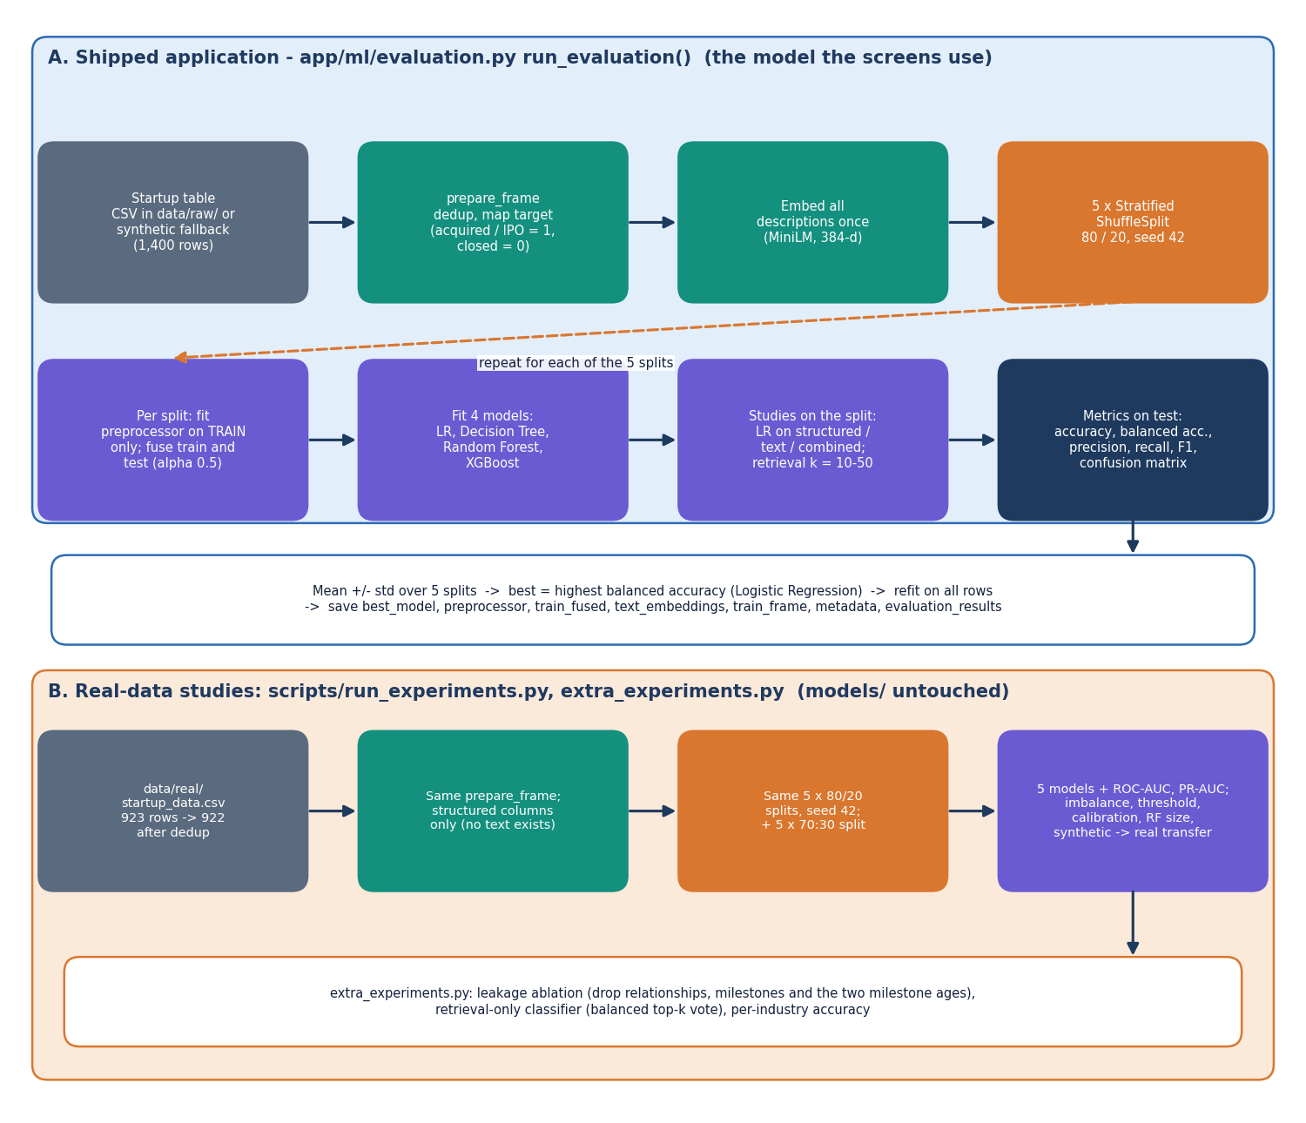
Figure 11: Evaluation protocol: (A) the study that selects the shipped model and (B) the studies on the real public table.
Part A is run_evaluation on the shipped table. The 1,400-row startup table is prepared, all descriptions are embedded once, and five stratified 80/20 splits (seed 42) are drawn. In each split the preprocessor is fitted on the training part only and the blocks are fused; four models are fitted; logistic regression is fitted on structured, text and combined vectors; and the similarity-weighted vote is scored for k = 10 to 50. The test metrics (accuracy, balanced accuracy, precision, recall, F1 and the confusion matrix) are averaged over the five splits, the model with the highest balanced accuracy is refitted on all rows and the artefacts and the evaluation file are saved. Part B repeats the protocol with scripts/run_experiments.py and scripts/extra_experiments.py on the real table (923 rows, 922 after de-duplication, structured columns only, no text): five models with ROC-AUC and PR-AUC, imbalance, threshold, calibration, forest-size, 70:30 and synthetic-to-real studies, the leakage ablation, the retrieval-only classifier and the per-industry accuracy.

